# 1.9 Source calibration system

Calibration and monitoring during data-taking is an important ingredient if the best possible performance of the calorimeter is to be realized. A suitable system must provide precise, independent crystal-by-crystal calibration. The use of radioactive sources is a proven technique for accomplishing such a calibration. However, most long-lived sources are limited to an energy around 1 MeV, which makes it difficult to secure a signal significantly above electronic noise, and sources that must be deployed individually are not practical with a system of ~2000 crystals. Mu2e has adopted an approach formerly devised for the BaBar electromagnetic calorimeter. In this system a 6.13 MeV photon line is obtained from a short-lived 16O transition that can be switched on and off arbitrarily. This system was successfully used for routine weekly calibrations of the BaBar calorimeter. It is an ideal match to the Mu2e requirements, and we have started the process of salvaging the BaBar system in order to refurbish it for use in Mu2e.

The decay chain producing the calibration photon line is*:*

The fluorine, a component of Fluorinert™ coolant liquid, is activated with a fast neutron source, producing the 16N isotope. This isotope then β-decays with a half-life of seven seconds to an excited state 16O*, which in turn emits a 6.13 MeV photon as it cascades to its ground state. A source spectrum collected with a BaBar CsI(Tl) crystal with PIN diode readouts is shown at right. There are three principal contributions to the overall energy distribution: one peak at 6.13 MeV, another at 5.62 MeV and a third at 5.11 MeV, the latter two representing e+e- annihilation photon escape peaks. Since all three peaks have well-defined energies, they simultaneously provide both an absolute calibration and a measure of the linearity of response at the low end of the calorimeter energy scale.

Figure . Typical source calibration spectrum from a BaBar CsI(Tl) crystal showing the 6.13 MeV peak, along with two escape peaks.

The fluorine is activated using neutrons provided by a commercial deuterium-tritium (DT) generator producing 14.2 MeV neutrons, at typical rates of several times 108 neutrons/second, by accelerating deuterons onto a tritium target. The DT generator is surrounded with a bath of the fluorine-containing liquid Fluorinert™, which is then circulated through a system of manifolds and pipes to the calorimeter crystals. Many suitable fluorine-containing liquids are commercially available; Fluorinert™ “FC-77” was used in BaBar and stored in a reservoir near the D-T generator. When a calibration run is started, the generator and a circulating pump are turned on. Fluid is pumped from the reservoir through the DT activation bath and then to the calorimeter. The system is closed, with fluid returning from the calorimeter to the reservoir. A schematic of the Mu2e system, based on the BaBar system, is shown below [NEED TO UPDATE FIGURE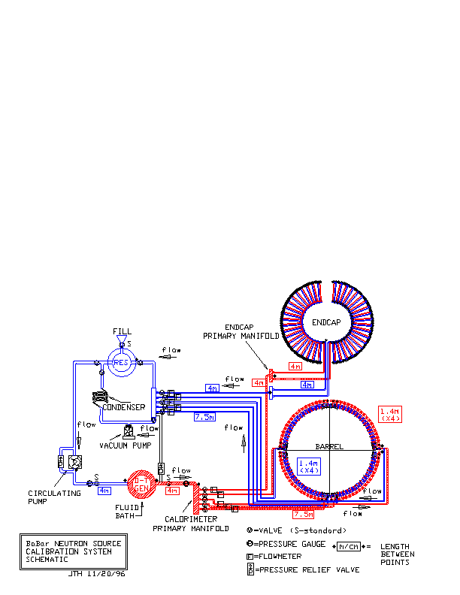].

Figure . Schematic layout of the BaBar EMC source calibration system.

The DT neutron generator is a small accelerator. Radiation safety protocols factor into the design of the calibration system, and operation of the source will be done remotely in a no-access condition. The half-life of the activated liquid is 7 seconds, and residual radioactivity is not a substantial concern when the DT generator is not operating. The DT generator produces 14 MeV neutrons, at a rate of several times 108 neutrons/second, and will be shielded according to FNAL safety regulations. The shielding will be interlocked such that the DT generator cannot be operated if the shielding is not in place. The fluid reservoir is capable of holding the entire volume of Fluorinert™ fluid required for operation of the system. In the event of a fluid leak, the maximum exposure for the BaBar system was calculated to result in a maximum integrated dose of less than 1 mrem; for Mu2e, a detailed hazard analysis will be performed in collaboration with FNAL radiation safety experts. Operation of the system is anticipated to be approximately weekly during Mu2e running.

In BaBar, the fluid was pumped at 3.5 liter/second, producing a counting rate of ~40 Hz in each of the ~6500 BaBar crystals, which were an average distance of about 12 m from the DT generator. This produced a calibration with a statistical uncertainty of ~0.35% on peak positions in a single crystal in a 10-15 minute calibration run. The fluid transport manifold consisted of thin-wall (0.5 mm) aluminum tubing (3/8-inch diameter); 1 mm of Al represents 1.2% of a radiation length. The tubes were placed in front of the BaBar crystals, with an additional 2 mm of Al in the structural support for the tube assemblies. A similar system of thin-wall aluminum tubing mounted on a supporting structure will be implemented for each of the two Mu2e calorimeter disks.

### Salvage of System Components from SLAC

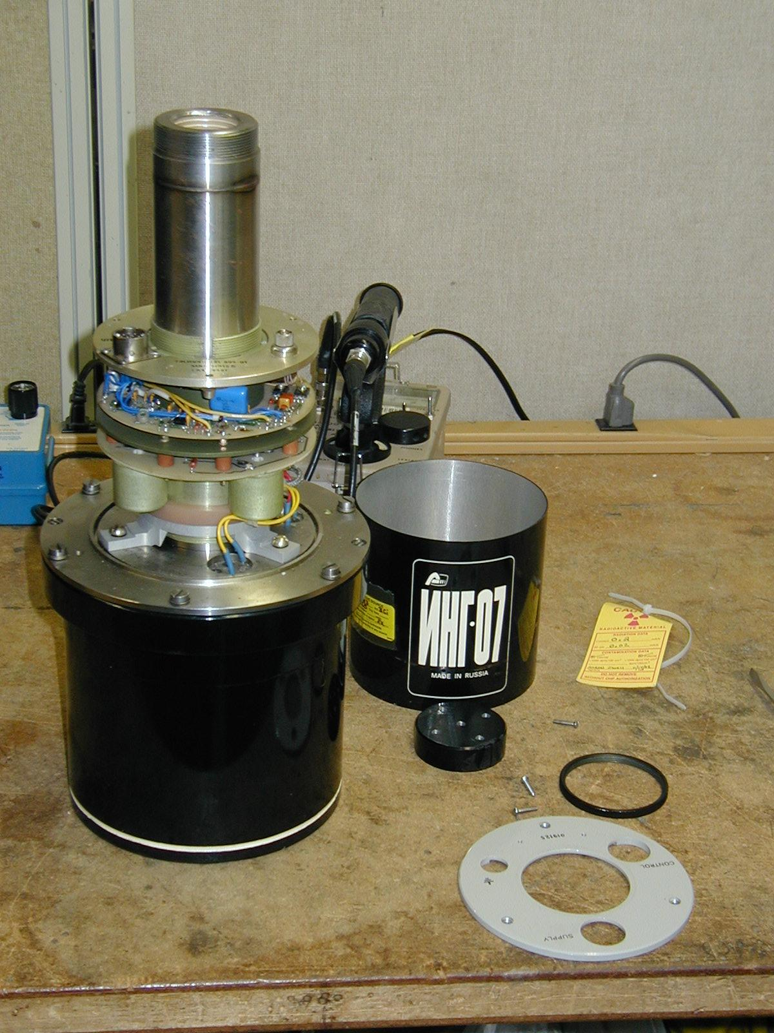Many of the main components of the source calibration system used at BaBar have been preserved in good condition during the BaBar detector decommission process and have been requested from SLAC. These items include:

Figure . The model ING-07 DT generator.

* the BaBar DT generator, model ING-07, manufactured by the All-Russia Institute of Automatics (shown partially disassembled prior to installation at BaBar in the photo at the right) , including HV power supply, PC-interface controller card and cabling;
* elements of the fluid distribution system, including the primary outgoing and incoming manifolds, valves and pressure gauges, and the main distribution panel on which many of these items are mounted;
* pumps for the fill and fluid activation loops; and
* any remaining stocks of Fluorinert™ FC-77.

### Implementation for Mu2e

The source calibration system for Mu2e is designed to provide a weekly calibration of the entire calorimeter in about 10 minutes of data acquisition each occurrence. The design precision is better than 0.1 MeV at the 6.13 MeV line, or better than 1.4%. This gives negligible contribution to the resolution of the calorimeter.

The number density of fluorine in Fluorinert FC-77 may be estimated as approximately 4x10^28 m^-3, essentially all in the desired 19F isotope. There is some uncertainty in this number density as the proprietary mixture is not precisely known; we work with a worst case assumption. The viscosity, at 0.8 centiStokes, is similar to water.

The relevant 19F(n,alpha)16N cross section is about 24 mb [A. Durusoy and I. A. Reyhancan, Annals of Nuclear Energy **33**, 159 (2006)]. The total inelastic cross section is around 80 mb, dominated by 19F(n,2n)18F. The elastic cross section is much larger, at about a barn.

The bath irradiated by the DT generator has a volume of about 20 l. It is pumped at a rate of 3.5 l/s. For a neutron rate of 10^9/s the density of 16N at the bath exit is thus about 1.5x10^9/m^3. With decays, this is attenuated by a factor of 0.7 by the time the fluid reaches the furthest crystals in the calorimeter.

The conceptual layout of the source calibration components is shown in Figure 4. The basic plumbing design consists of 3 cm inside diameter transport pipes of about 15 m length to the calorimeter disks, where 3 cm manifolds are located. Each disk has two such manifolds, one for supply and one for return. Connecting the manifolds are the thin-wall tubes that carry the irradiated fluid over the face of the calorimeter disk. There are 12 of these for each disk, arranged in a concentric pattern and ranging in length from 1.5 to 1.7 m. The tubes are 0.5 mm wall thickness round aluminum tubing with an inside diameter of 3/8 inch.

Including pessimistic geometric assumptions, the rate of calibration photons in each crystal is about 25 Hz per 10^9 n/s from the DT generator. The required precision corresponds to about 5 Hz, so a DT generator with a few times 10^8 n/s is sufficient.

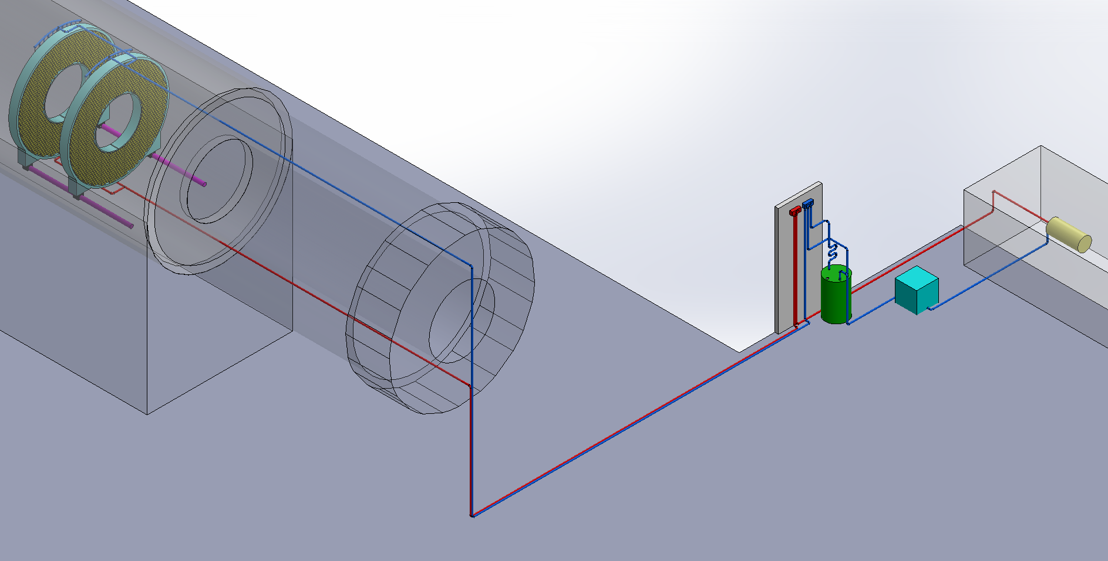

Figure . Physical layout of the calibration source components in the Mu2e experimental hall.

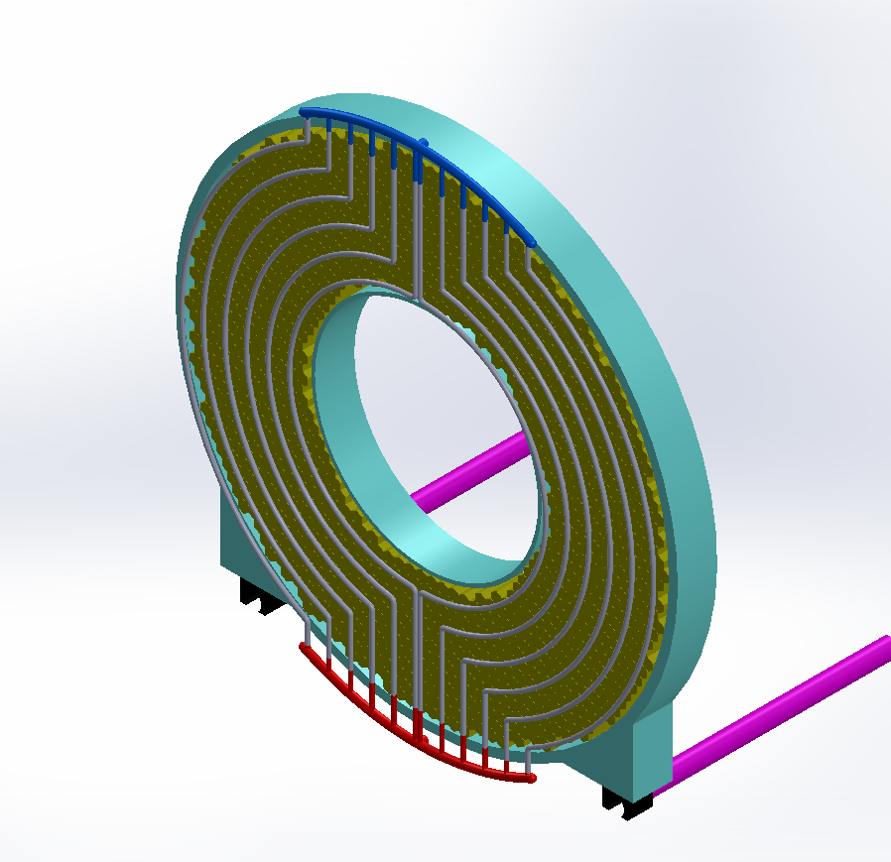Figure 5 shows the layout of Al pipes at the front face of a calorimeter disk, along with the manifolds at bottom (red) and top (blue) that lead to and from the fluid activation bath. Studies using as a figure-of-merit the number of photons passing through a surface element at the front face of a crystal have been performed to optimize the spacing between pipes and the perpendicular distance from the pipes to the front surface of the crystals. Figure 6 demonstrates the ±10% variation in illumination as a function of increasing radial distance for an inter-pipe spacing of 60 mm and 30 mm between pipes and the front surface of the crystals. Figure 7 shows the relative intensity for different values of the distance between pipes and the crystal front surface as a function of radial distance. Based on these studies, we have chosen to set the distance between pipes to 60 mm, which essentially allows one pipe to pass between every other crystal. The distance from the pipes to the crystal front surface should be minimized but, as can be seen from the figure, any distance between approximately 10-30 mm is reasonable. The final value for the perpendicular distance will be determined within this window taking into account any engineering constraints.

Figure 5. Calorimeter disk with source calibration Al pipes.

Figure 7. Simulation of the relative intensity of illumination as a function of radial distance for several values of the distance between the pipes and the front surface of crystals.

Figure 6. Simulation of the radial variation in illumination by the activated fluid circulating in Al pipes with an inter-pipe spacing of 60 mm and 30 mm between the pipes and the front surface of the crystals.